20/02/2020

Buyer:
..........................................................
..........................................................

Quotation UT__/20

Thank for your kind request. Below our best offer for the supply of the services described below. Consider us at your disposal for any further information you may require. Kind regards.

SPECIFIC SUPPLY CONDITIONS

1) PRICES: V.A.T. not included, and when applicable it will be charged to the customer.
2) DESTINATION: your head office.
3) DELIVERY: EVERY WEEK at the order confirmation in any case according to the producers availability.
Delivery and transport costs at BUYER expenses.
4) PAYMENT: 70% at order confirmation, 20% when products are ready to be shipped, 10% on delivery.
5) WARRANTY: new: 12 months from the shipping note date, according to the producers specifications; used: 4 months from
the shipping note date according to the law.
6) CERTIFICATION
7) VALIDITY OF THIS OFFER: 30 days at compilation date.

As for what is not expressly stated in the above listed Particular Supply Conditions, please refer to the enclosed General Supply Conditions which are part of the present offer.
General supply conditions
1) GENERALITIES: the present conditions regulate any goods and services provision contract by…………..,
hereafter indicated as “seller”, hence, every and any condition stated in the purchaser order or in any other document which emerges to be in contrast is meant automatically annulled. The term “goods” includes single equipments, parts, accessories, reparations, assistance and planning if required by the standard supply. The absence of the present sale general conditions, causes this offer invalidity.

2) PRICE VARIATION: The seller reserves the right to charge possible differences due to change alterations, customs and import fee occurred between the order and the delivery date.

3) DELIVERY: The delivery terms stated are merely indicative, so their possible inobservance does not give the purchaser the faculty to remit the order or to claim for any damage. The seller, however, undertakes to do his utmost for the delivery terms to be respected. The delivery terms become effective at the acceptance of the order.

4) PAYMENTS: Orders will be accepted on condition that the payment will be done on time and currency agreed in the offer. The seller reserves the right not to do any delivery until all the debts related to the previous delivery will be extinguished and to remit any contract in case of delayed payment.
The seller reserves the faculty to require eligible guaranty to backup the sum owed; warranty considered insufficient by the indisputable opinion of the Management imply automatically the resolution of the present contract. Interests will be charged in case of delayed payment, for the prime rate in force at the invoicing increase of five per cent.

5) TRANSPORT DAMAGES: F.O.B. our ware house.It is understood that the risk of the goods transport is charged to the purchaser.

7) ORDER CANCELATION: should the purchaser decide to cancel an already issued order, the seller reserves the right to charge him all the expenses related to the order, and the possible damage.

Rif | Code | Description |  |  | Qty.  pieces | Unit Price | Total price
1 | Face Mask  3P – K CLASS FFP1 | 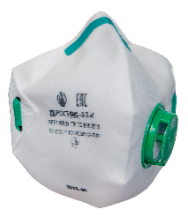    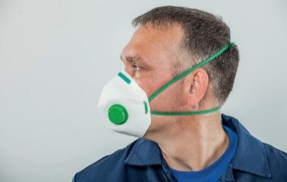  Flat-folding with a vertical axial seam half-mask (in the designation of the model - the letter “P”). The main advantage: it has a reliable line of obturation, can be comfortably stored in your workwear pocket. In the folded state, the ingress of dust and dirt on the inner surface of the half mask is minimized. It is equipped with an exhalation valve, which provides heat and moisture removal from the mask space, re- duces breathing resistance in conditions of elevated temperature and humidity. To ensure a snug fit in the nose bridge, a nose clip and a shock-absorbing lining are installed under it. Resistant to clogging and dust (“NR D”). The rubber-fabric tape (headset) is attached to the grommets with a single harness, which reduces the risk of separation from the respirator during operation and  automatically distributes the ten-  sion of the fastening in the neck and neck. The working filter surface to the obturation line is not violated. The warranty shelf life of half masks from the date of manufacture is 3 years.  Appointment: protection of respiratory organs from coarse mineral and organic (animal and vegetable origin), as well as synthetic solid aerosols.  Nominal protection factor 4.  Scope: mining, metallurgy (including the production of non-ferrous metals and steel), coke production, machine building, shipbuilding, production of building materials, pharmaceutical, food industry, agriculture, in everyday life. |  |  |  | € 2,30
2 | Face Mask  3F – K  CLASS FFP1 | 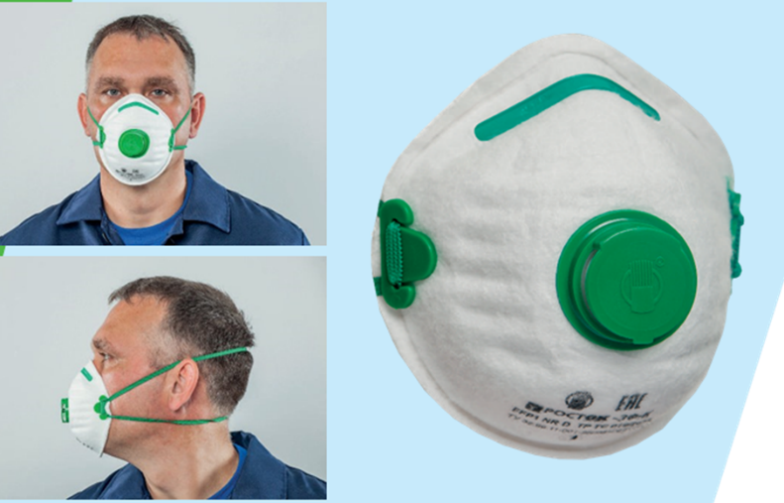  The half mask is made of highly effective polypropylene filtering material, has a cup-shaped (molded) shape with stiffeners, which gives the half mask the ability to hold the shape in case of crushing. It is equipped with an exhalation valve, which provides heat and moisture removal from the under-mask space and reduces breathing resistance in conditions of elevated temperature and humidity. To ensure a snug  fit in the nose bridge, a nose clip and a shock-absorbing lining are installed under it. Resistant to clogging and dust (“NR D”). The rubber-fabric tape (headset) is attached with a knot using special plastic eyes, which makes it possible to individually fit to the face, reduces the risk of separation from the respirator during operation. The warranty shelf life of half masks from the date of manufacture is 3 years.  Appointment: protection of respiratory organs from coarse mineral and organic (animal and vegetable origin), as well as synthetic solid aerosols.  Nominal protection factor 4.  Scope: mining, metallurgy (including the production of non-ferrous metals and steel), coke production, machine building, shipbuilding, production of building materials, pharmaceutical, food industry, agriculture, in everyday life. |  |  | 200.000 | € 2,50
3 | Face Mask  2F – K  CLASS FFP2 | 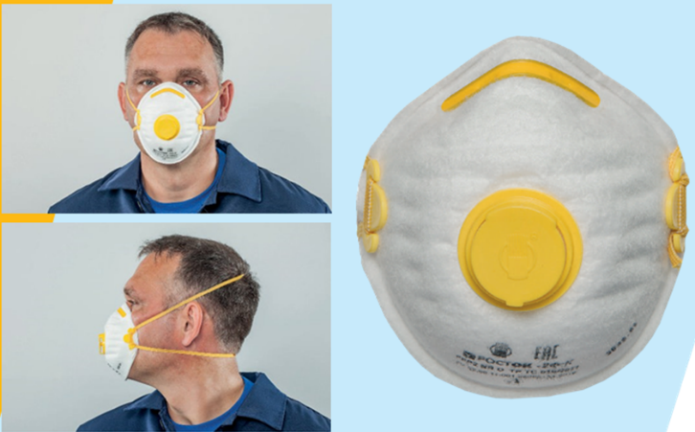  The half mask is made of highly effective polypropylene filtering material, has a cup-shaped (molded) shape with stiff- eners, which gives the half mask the ability to hold the shape in case of crushing. It is equipped with an exhalation valve, which provides heat and moisture removal from the mask space, reduces breathing resistance in conditions of elevated temperature and humidity. To ensure a snug fit a nose clip and a shock-absorbing lining under it are installed in the nose bridge area. Resistant to clogging and dust (“NR D”). The rubber-fabric tape (headset) is attached with a knot using spe- cial plastic eyes, which makes it possible to individually fit to the face, reduces the risk of separation from the respirator during operation. The warranty shelf life of half masks from the date of manufacture is 3 years.  Appointment: protection of respiratory organs from fine solid and liquid aerosols (including soot, welding smoke, oil mist)  Nominal protection factor 12.  Scope: are applied in the mining, metallurgical industry (including production of non-ferrous metals and steel); cement, textile, construction (grinding, cutting, drilling, drilling, etc.), woodworking, food industry (bakeries, sugar factories, starch enterprises, tobacco, tea factories, etc.), in instrument, machine and machine tool building,  shipbuilding; in the pharmaceutical industry, when working with powdered chemicals; in the processing of glass and mineral fiber materials; in industries using electric, gas welding or metal cutting, soldering. And also in agriculture and in everyday life when processing garden plants from pests, during repair and construction works at home. |  |  | 200.000 | € 2,80
4 | Face Mask  2T –  CLASS FFP2 | 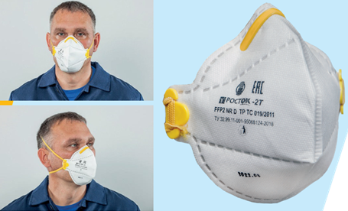  The half mask is made of highly effective polypropylene filtering material, has a cup-shaped (molded) shape with stiff- eners, which gives the half mask the ability to hold the shape in case of crushing. It is equipped with an exhalation valve, which provides heat and moisture removal from the mask space, reduces breathing resistance in conditions of elevated temperature and humidity. To ensure a snug fit a nose clip and a shock-absorbing lining under it are installed in the nose bridge area. Resistant to clogging and dust (“NR D”). The rubber-fabric tape (headset) is attached with a knot using spe- cial plastic eyes, which makes it possible to individually fit to the face, reduces the risk of separation from the respirator during operation. The warranty shelf life of half masks from the date of manufacture is 3 years.  Appointment: protection of respiratory organs from fine solid and liquid aerosols (including soot, welding smoke, oil mist)  Nominal protection factor 12.  Scope: are applied in the mining, metallurgical industry (including production of non-ferrous metals and steel); cement, textile, construction (grinding, cutting, drilling, drilling, etc.), woodworking, food industry (bakeries, sugar factories, starch enterprises, tobacco, tea factories, etc.), in instrument, machine and machine tool building,  shipbuilding; in the pharmaceutical industry, when working with powdered chemicals; in the processing of glass and mineral fiber materials; in industries using electric, gas welding or metal cutting, soldering. As well as in agriculture and in everyday life when processing garden plants from pests, during repair and construction work at home. |  |  | 200.000 | € 2,70
5 | Face Mask  1T – K  CLASS FFP3 | 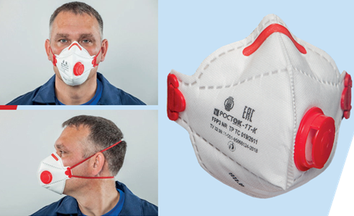  Half-folding with a vertical axial seam half mask with exhalation valve. The design ad- vantage is additional stiffening ribs that provide more comfortable operation, retain the shape of a respirator when working in conditions of elevated temperatures and humid- ity. To ensure a snug fit in the nose bridge, a nose clip and a shock-absorbing lining are installed under it. The respirator has a reliable obturation line, is equipped with an ex- halation valve, which provides heat and moisture removal from the mask space, reduces breathing resistance, can be stored comfortably in your workwear pocket. In the folded state, the ingress of dust and dirt on the inner surface of the half mask is minimized. Re- sistant to clogging and dust (“NR D”). The rubber-fabric tape (headset) is attached with a knot using special plastic eyes, which makes it possible to individually fit to the face,  reduces risk of separation from the respirator during operation. The warranty shelf life of half masks from the date of manufacture is 3 years.  Appointment: Protection of respiratory organs from fine solid and liquid aerosols of heavy metals, radioactive and microbiological aerosols  Nominal protection factor 50.  Scope: Nuclear plants, biochemical laboratories, radiochemical production; work on power units (when replacing filters) |  |  | 200.000 | € 3,70
 |  |  |  |  | pieces |  | €
1 | MONTH | MARCH 2020 Total masks x month |  |  | 1.000.000
2 | MONTH | APRIL 2020 Total masks x month |  |  | 1.000.000
3 | MONTH | MAY 2020 Total masks x month |  |  | 1.000.000
4 | MONTH | JUNIE 2020 Total masks x month |  |  | 1.000.000
5 | MONTH | JULIE 2020 Total masks x month |  |  | 1.000.000
6 | MONTH | AUGUST Total masks x month |  |  | 1.000.000
 |  | Total Masks |  |  | 6.000.000
 |  |  | Total EURO

Buyer signature for acceptance: For
X……………………………………………………………

According to the articles 1341 and 1342 C.C. are expressly accepted clauses n. 5 and 6 of the particular supply conditions and the clauses 1, 2, 3, 4, 5, 6, 7, e 8 of the General Supply Conditions.

Buyer signature for acceptance: For
X……………………………………………………………

AGREEMENT REGARDING PERSONAL DATA PROCESSING
The purchaser confirms to have been informed in advance on what is contemplated by the Decree Legislative n. 196 of 30/6/2003 and expressly agree that the data related to the execution of the present contract report and every possible subsequent, will be handled and transmitted to third parties within the limits of law.

EVENTUAL CONSENT FOR PROMOTIONAL ACTIVITIES.
The purchaser, furthermore (cross out the side you are not interested in) agrees does not agree
That his personal data will be handled by the seller and/or transmitted to third parties that carry out commercial and promotional activities and for marketing purposes here included the sending of information material regarding commercial services and items.

Buyer signature for acceptance: X…………………………………………………………………

